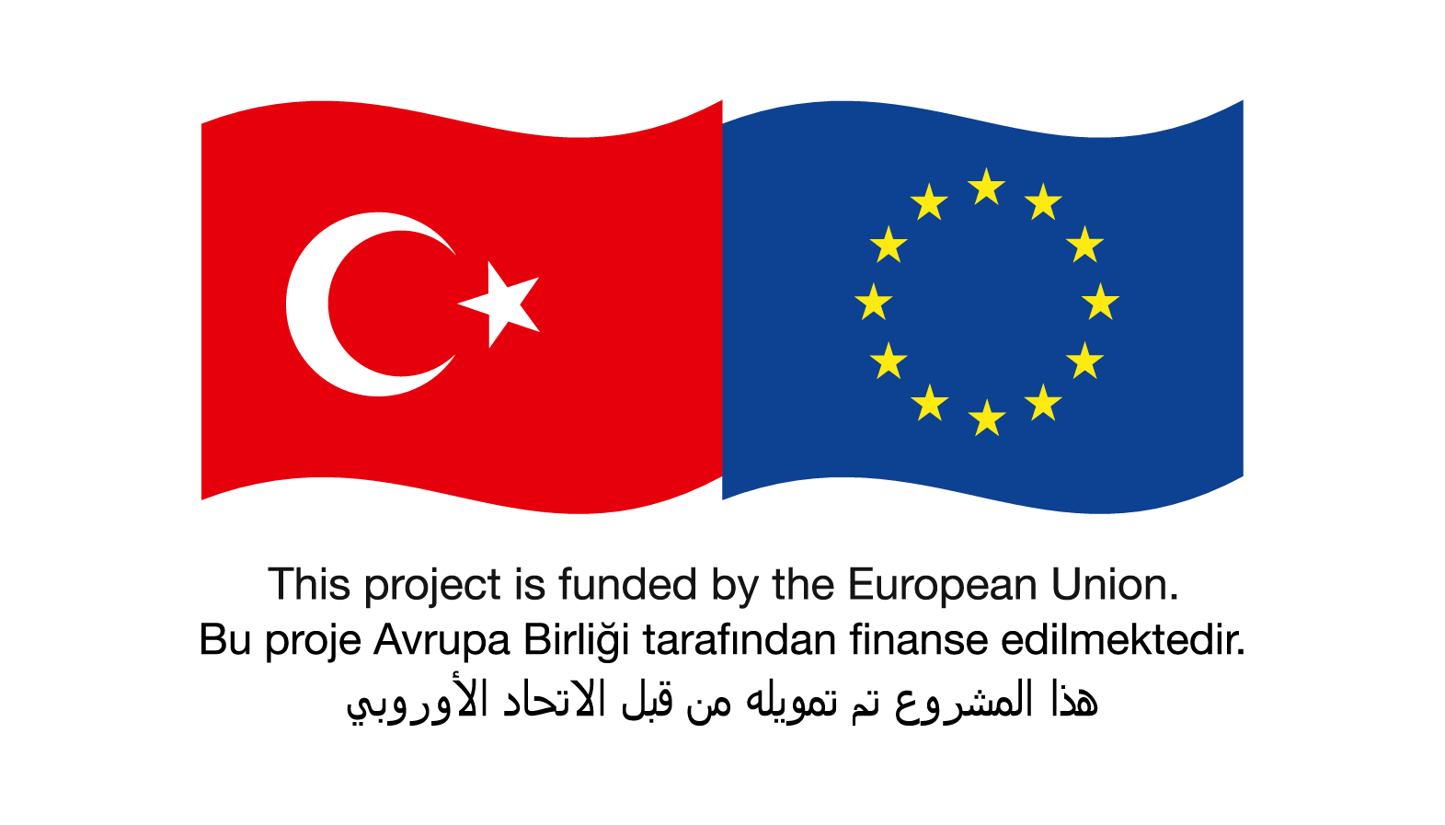
Project Title | Integrating Syrians into Turkish Higher Education through Recognition of Qualifications (REFREC-TR)
Duration | 10 months, December 2017 – October 2018
Grant Programme | HOPES (Higher and Further Education Opportunities and Perspectives for Syrians) within the European Union’s Regional Trust Fund in response to the Syrian Crisis, ‘the Madad Fund’
Coordinator | Yaşar University UNESCO Chair on International Migration
Partners | - Ministry of Interior, İzmir DG Migration Management  - Norwegian Agency for Quality Assurance in Education (NOKUT)
Project Aim | - To develop a comprehensive, functional and tailor-made recognition tool for Turkish higher education concerning Syrians with documents that needs to be validated and more specifically Syrians without proper documents  - To publish a comparative research report and a guideline for Turkish higher education system by conducting an evidence-based academic research on how to better cope and integrate Syrians and prospective refugees into Turkish higher education system.
Expected Outputs | - Increased knowledge and experience through testing NOKUT’s “Qualifications Passport for Refugees” for Turkish case  - A new suggestion of methodology based on academic research concerning the recognition of refugees’ qualifications  - A new report and guide for researchers, officials, experts and policy makers working for/with refugees.  - Academic articles published in respected journals  - Increased knowledge of expert credential evaluators through the training on interviewing refugees in assessing their qualifications
Team Members | - Ayselin Yıldız, Coordinator, Yaşar Üniversitesi  - Arıkan Açar, Senior Researcher, Yaşar Üniversitesi  - Stig Arne Skjerven, Expert/Advisor, NOKUT  - Marina Malgina, Expert/Advisor, NOKUT  - Einar Meier, Expert/Advisor, NOKUT  - Tugba Uylas, Policy Officer, Izmir DG Migration Management  - Selin Sivis, Researcher  - Zeynep Ozde Atesok, Researcher
Contact | Ayselin YILDIZ  Yaşar Üniversitesi  UNESCO Chair on International Migration  Tel: (232) 570 88 51 veya 544 297 3546  ayselin.yildiz@yasar.edu.tr
Website | https://unescochair.yasar.edu.tr/

