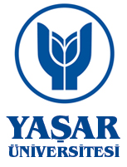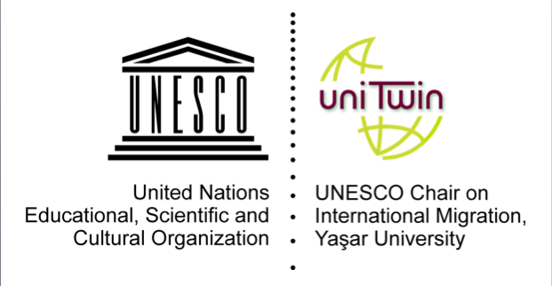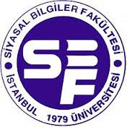

“Migration Trends in the Mediterranean and Regional Policy Responses”

Istanbul University

November 20, 2017

09:30-10:00  SESSION I | Welcoming Speech  - Prof.Dr.Ayşegül KOMSUOĞLU (Dean, Faculty of Political Sciences, Istanbul University)  - Assist.Prof.Dr.Ayselin YILDIZ (UNESCO Chair on International Migration, Yaşar University)  - Mr.Ahmet ÖNAL, Vice-Governor, Istanbul
 | Chair: Assist.Prof.Dr. Arıkan AÇAR (Vice-Director, Center for Mediterranean Studies, Yaşar University)
10:00-10:20 | EU Management of Migration Crisis: Policy responses from Italy  Prof.Dr.Fulvio ATTINA (University of Catania)
10:20-10:40 | Management of Migration Flows: Policy responses from Greece  Dr. Dimitris SKLEPARIS (Hellenic Foundation for European and Foreign Policy/ELIAMEP and University of Glasgow)
10:40-11:00 | Populist Responses to Migration in the EU  Prof.Dr. Ayhan KAYA (Jean Monnet Chair of European Politics of Interculturalism, Bilgi University)
11:00-11:45 | Q&A
12:00-13:30  SESSION II | Lunch
13:30-13:50 | Chair: Assoc.Prof.Dr. Kerem GİRAY (Faculty of Law, Istanbul University)  Management of Migration Flows: Policy responses from Turkey  Assist.Prof.Dr. Ayselin YILDIZ (Faculty of Human and Social Sciences, Yaşar University)
13:50-14:10 | Change in Health Policy: An Analysis of Primary Health Care Provision for Syrian Refugees  Assist.Prof.Dr. Ceren Ark YILDIRIM (Faculty of Political Sciences, Istanbul University)
14:10-14:30 | Turkish Society and the Changing Dynamics of Migrants’ Profile in Turkey  Assoc.Prof. Dr. Yusuf ADIGÜZEL (Faculty of Literature, Istanbul University)
14:30-14:50  14:50-15:15 | Humanitarian aspect of security-migration nexus  Assist.Prof.Dr. Pelin SÖNMEZ (Kocaeli University)  Comments and Suggestions
19:00 | Dinner

All the presentations will be published as a policy brief.

